PERTH AMBOY RACING PIGEON CLUB
806 CENTRAL PLACE PERTH AMBOY, N.J. 1-732-826-6264
www.perthamboyrpc.com
2018 PERTH AMBOY FUTURITY

“PAOF”

350 MILE BAND RACE
2500 POINTS
GUARANTEED TO THE WINNER

Ship Friday October 26, 2018
Liberate Sunday October 28, 2018
From Cadiz, Ohio

Baskets Close at 10:00 pm
Reporting Sunday night 7:00-9:00pm

Bands 10.00 each, 6 for 50.00, 12 for 100.00
Bonds 6 for 100.00, 12 for 200.00, 18 for 300.00
Designate your own bands before August 1, 2018

Clocks accepted: Standard wind-up and Quartz Clocks
Bricon, Benzing and Taurus Scanning Systems only

Bands can be purchased from your club band secretary or
Stanley Krawiec 4 Villanova Dr Manalapan, N.J. 07726 732-446-4842
Charles Zerafa 7 Fielek Terr. Parlin, N.J. 08859 732-727-6455

PAOF One Bird Derby
Shipped with and liberated before the band race
Entry $50.00 plus shipping and committee
The following prizes are based on 50 lofts
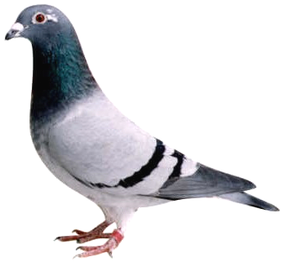
First 1000 points
Second 500 points
Third 400 points
Fourth 300 points
Fifth 200 points
Sixth 100 points
Prize increase/decrease based on lofts shipped
The same clock is used for both races

PERTH AMBOY RACING PIGEON CLUB
806 CENTRAL PLACE PERTH AMBOY, N.J. 1-732-826-6264
www.perthamboyrpc.com
2018 PERTH AMBOY FUTURITY

“PAOF”

350 MILE BAND RACE
2500 POINTS
GUARANTEED TO THE WINNER

Ship Friday October 26, 2018
Liberate Sunday October 28, 2018
From Cadiz, Ohio

Baskets Close at 10:00 pm
Reporting Sunday night 7:00-9:00pm

Bands 10.00 each, 6 for 50.00, 12 for 100.00
Bonds 6 for 100.00, 12 for 200.00, 18 for 300.00
Designate your own bands before August 1, 2018

Clocks accepted: Standard wind-up and Quartz Clocks
Bricon, Benzing and Taurus Scanning Systems only

Bands can be purchased from your club band secretary or
Stanley Krawiec 4 Villanova Dr Manalapan, N.J. 07726 732-446-4842
Charles Zerafa 7 Fielek Terr. Parlin, N.J. 08859 732-727-6455

PAOF One Bird Derby
Shipped with and liberated before the band race
Entry $50.00 plus shipping and committee
The following prizes are based on 50 lofts
First 1000 points
Second 500 points
Third 400 points
Fourth 300 points
Fifth 200 points
Sixth 100 points
Prize increase/decrease based on lofts shipped
The same clock is used for both races

